**Semi-Structured Data Hands On**

**Step 1: Set Context and Create JSON file format.**

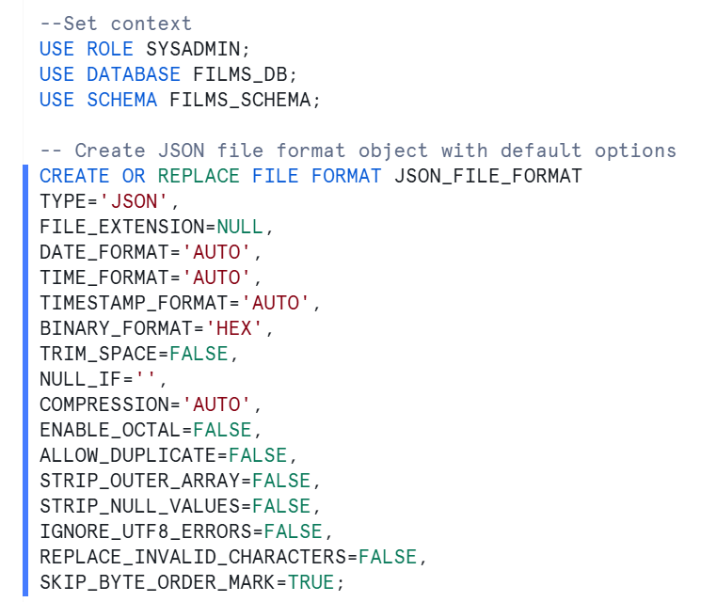

**Step2 : Open powershell and using put command copy the data to the internal Named stage**

**Command 1:**

cd 'C:\Program Files\Snowflake SnowSQL\'

**Command 2:**

snowsql -a HOJZGKX-QY24209 -u geedhuvj -d FILMS_DB -s FILMS_SCHEMA -r SYSADMIN -w COMPUTE_WH

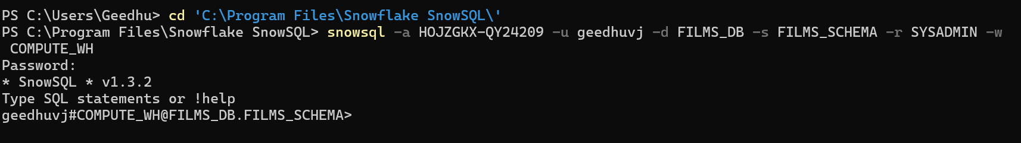

***Command 3:*** PUT file://C:\Users\Geedhu\Documents\Geedhu\Snowflake\Udemy\SnowPro_Core_Course_Hands-on_Resources\Hands-on-Queries\D3\films.json @FILMS_STAGE auto_compress=false;

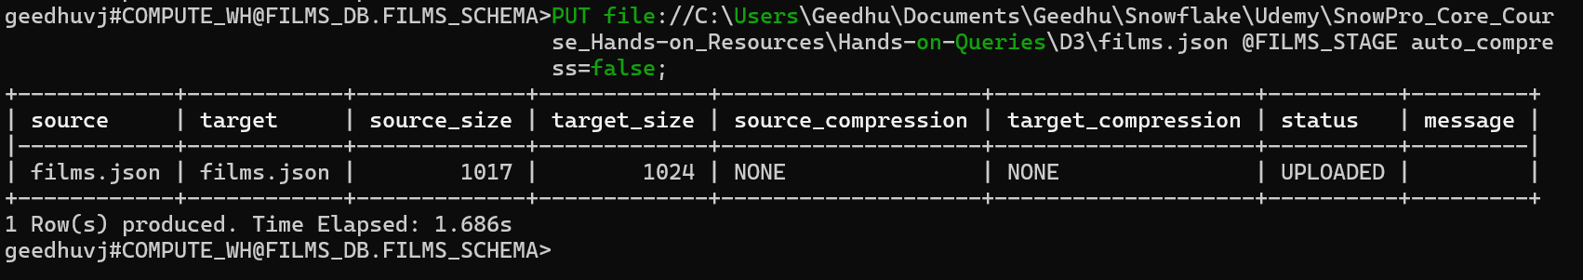

**Step 3: Understanding ELT**

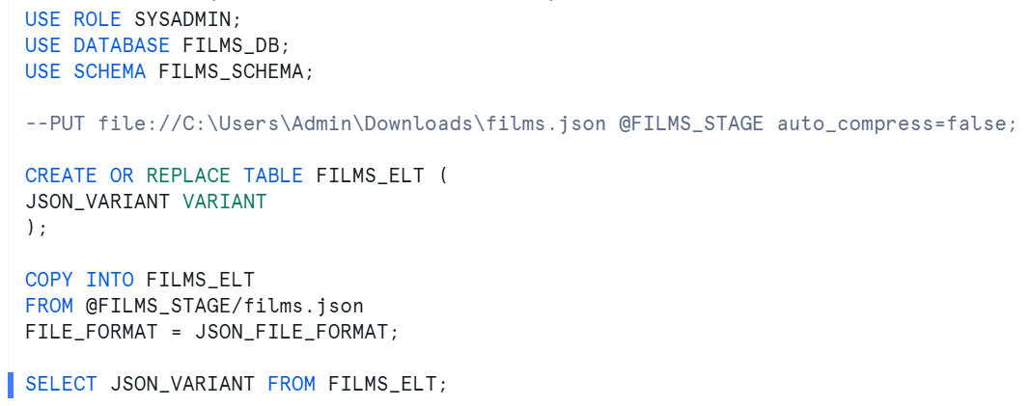

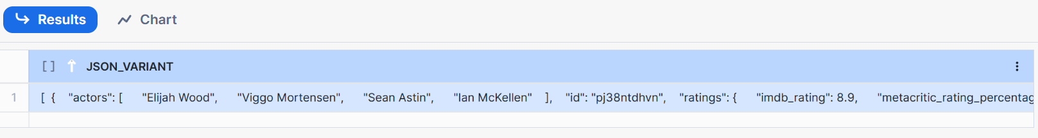

Step 3a: in a row only 16 MB can be stored so if file exceeds 16 MB, how to get the entire data is by setting in JSON file format “Strip_outer_Array= true”, this way it remove all brackets and entire file will be considered.

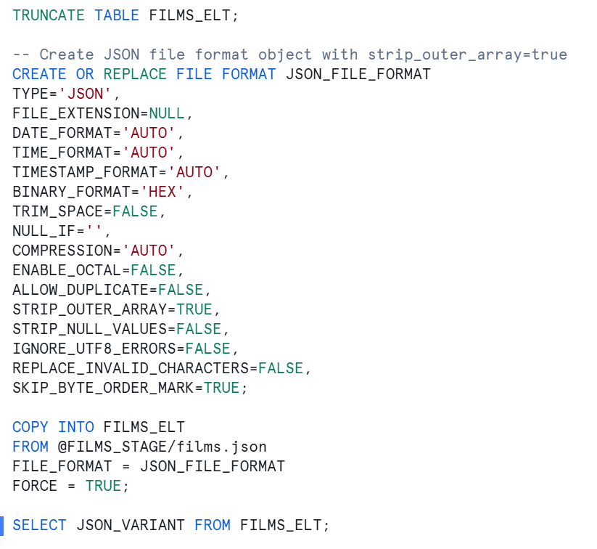

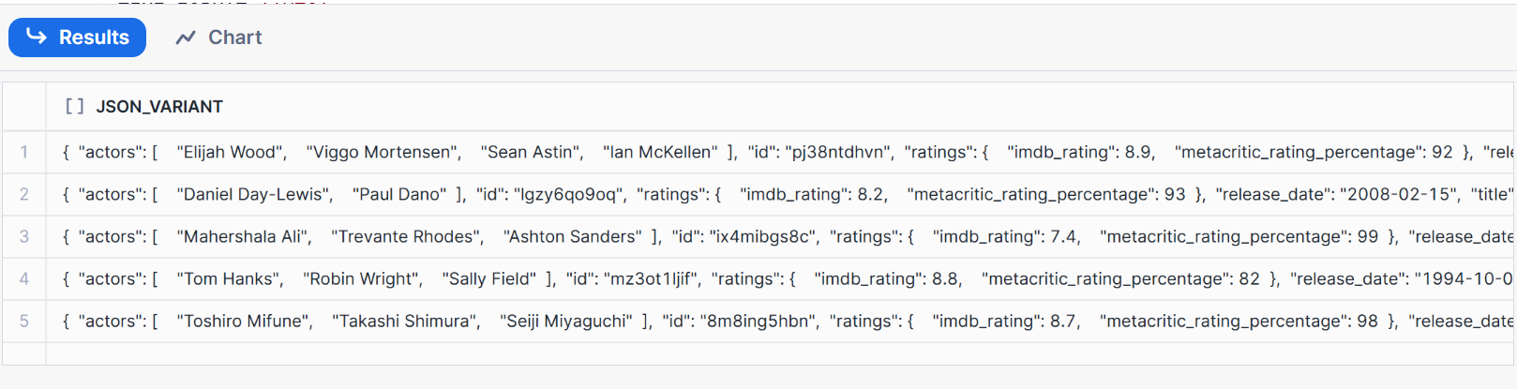

**Step 4: Query Semi Structured Data**

**Query 1:**

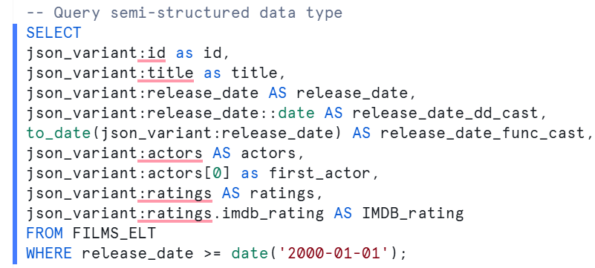

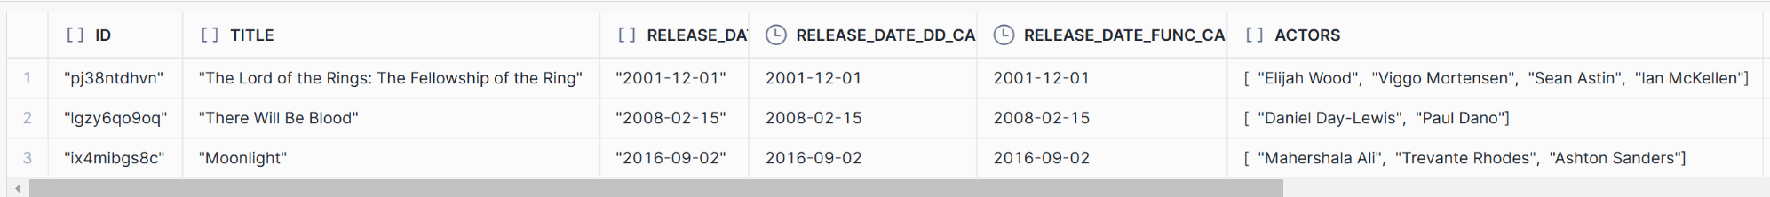

**Query 2:**

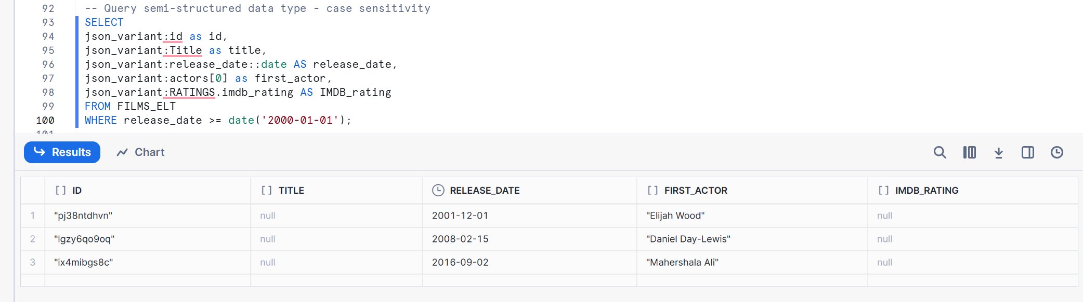

**Query 3:**

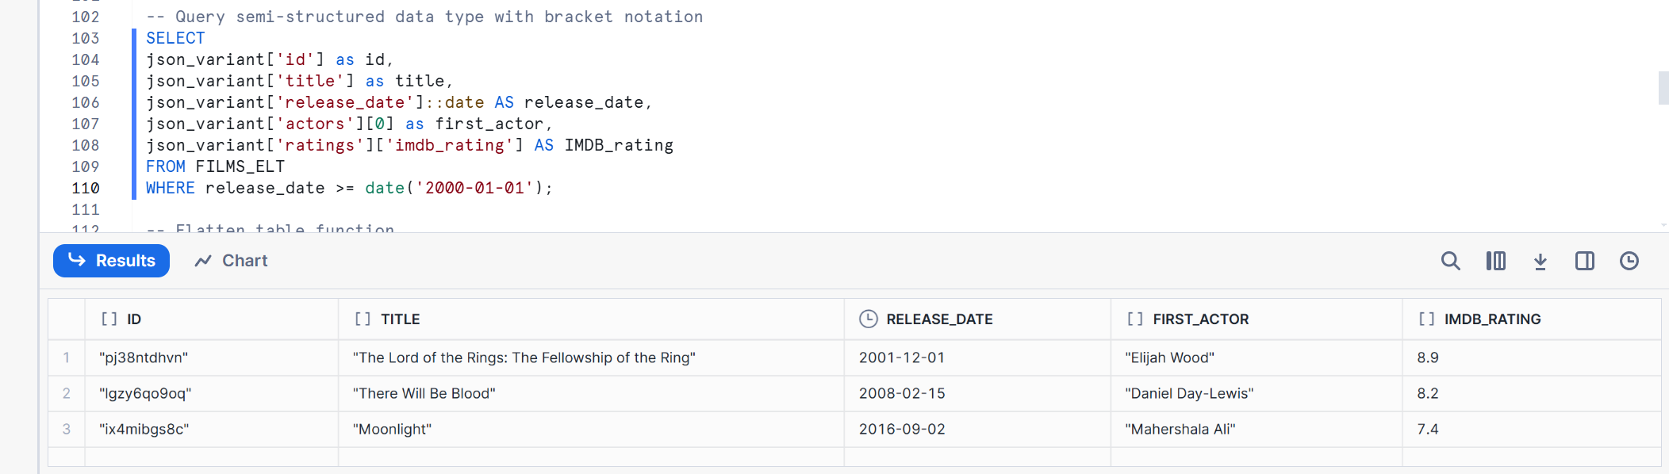

**Step 5: Using FLATTEN TABLE Function**

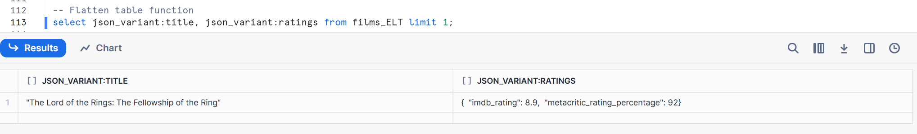

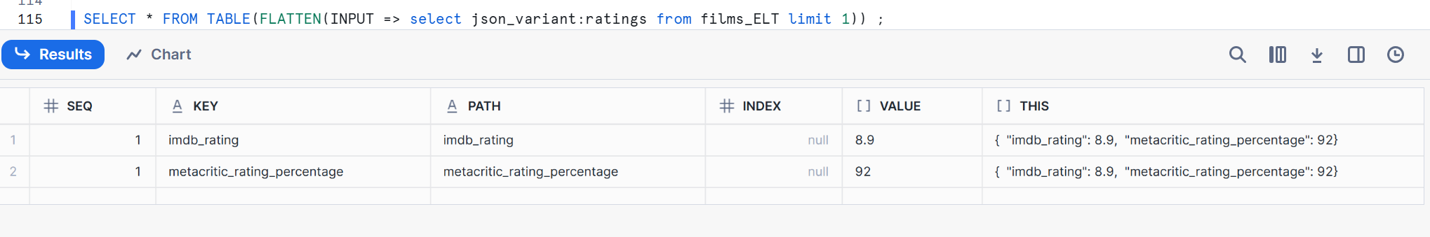

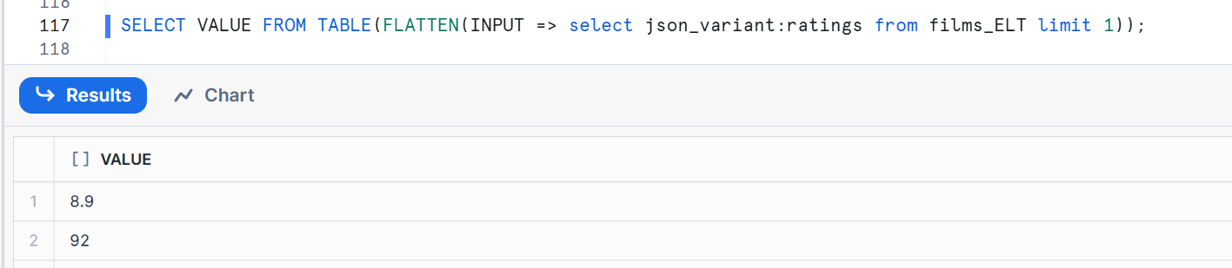

**Step 6: Using LATERAL FLATTEN Function**

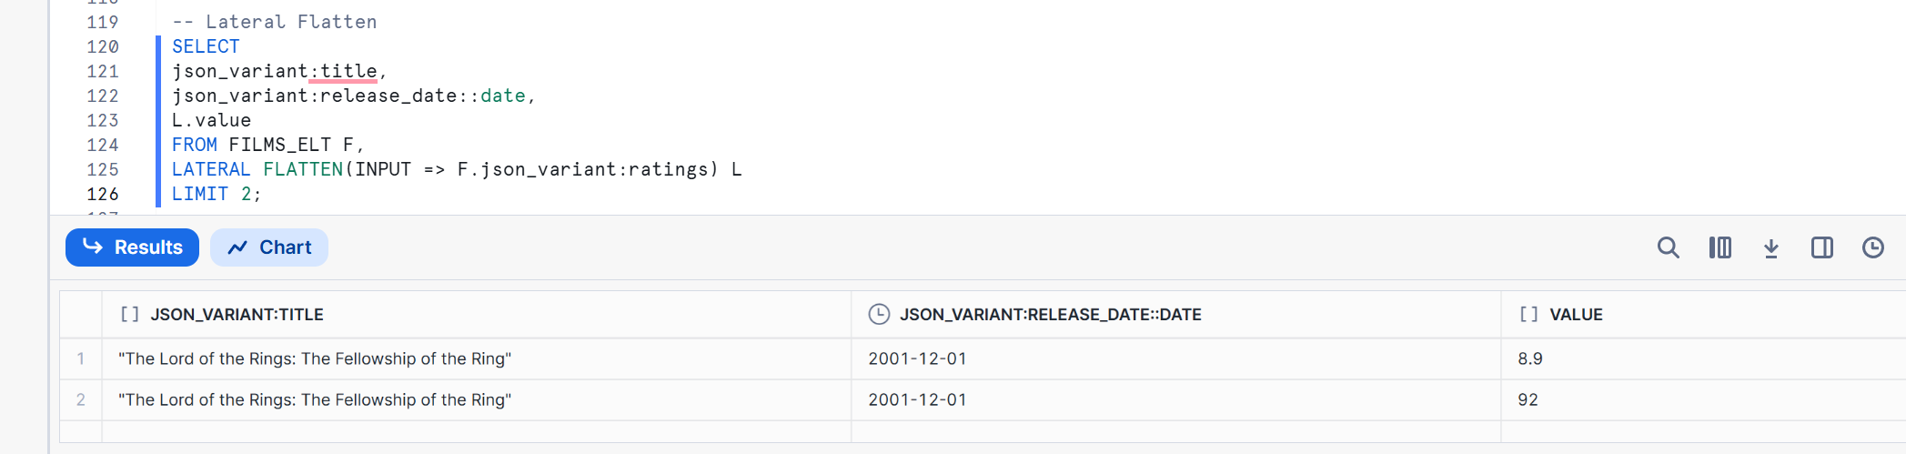

**Step 7: ETL**

**Create Table**

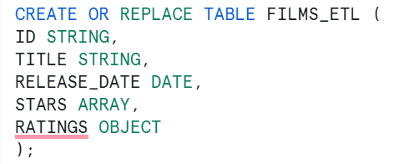

**Copy into Table**

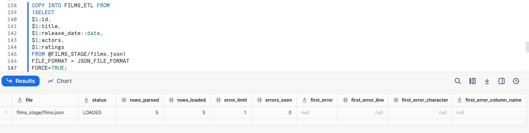

**Display Table values**

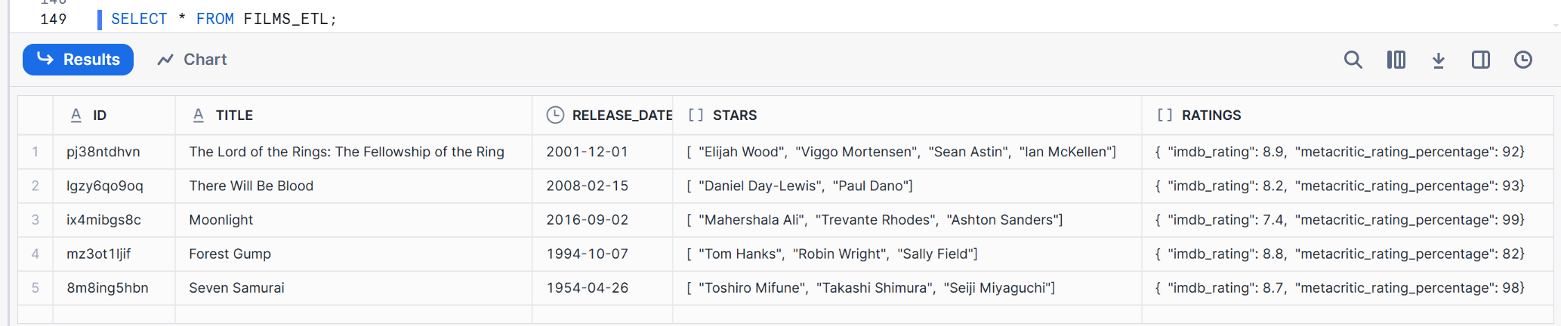

**Step 8: Using Match by Column option for automatically loading data to table**

